**OFFLINE CONTENT EDITOR** **EDIT**

EXPORTING CONTENT

The Content Editor Edit module can be located on the Home ribbon in the Edit Offline section.

There will be two buttons: Export and Import

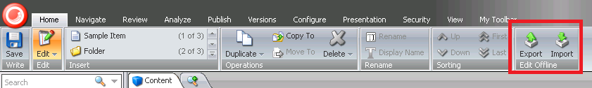

To begin exporting of content, press the Export button

You will be prompted by the Export Wizard. Press the Next button

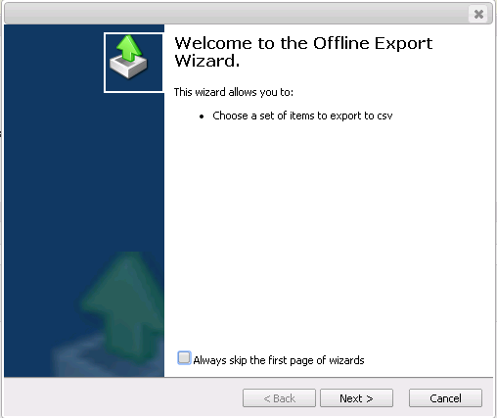

You will then be prompted to select the template type that you want to export. Select the Template type that you want to export in the drop down list. Once you have selected the template, press the Next button.

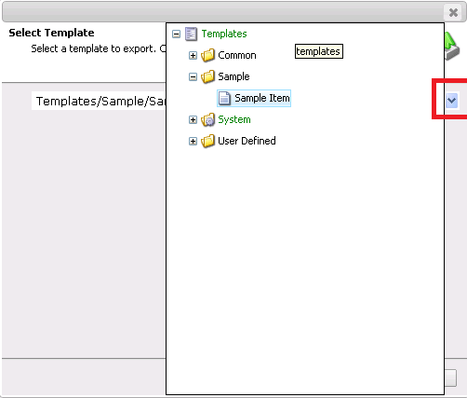

After selecting the Template type you want to export, you will be prompted to select the Fields that you want to export. Press the Select Fields button to begin selecting the fields.

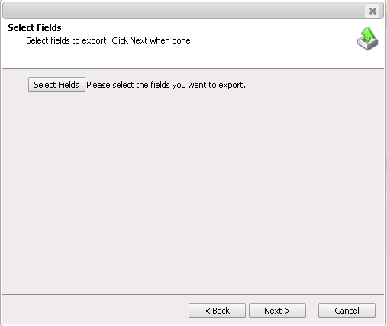

Once you have selected the Fields that you want to export, press OK.

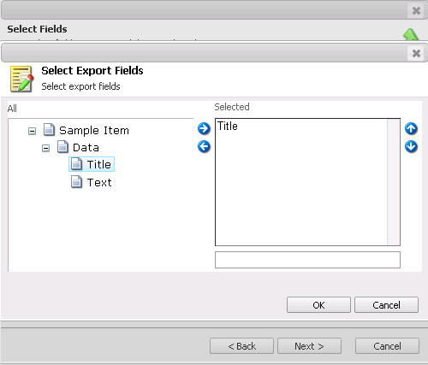

After you have selected the Fields, press the Next button in the wizard to continue to generating the file.

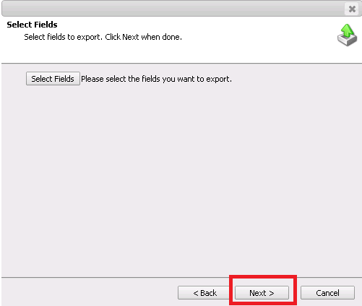

You will now be prompted with the final step in the wizard. You can download the generated file by clicking the download icon (below in red square). If you do not want to download the file, you may complete the wizard by pressing the Finish button.

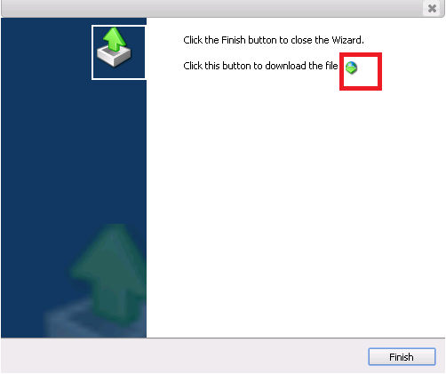

Technical note: The location of the download and upload path for the module is located in the OfflineContentEditor.config located in the AppConfig\Include folder of the solution.

IMPORTING CONTENT

To begin the process of importing content, press the Import button in the Home ribbon.

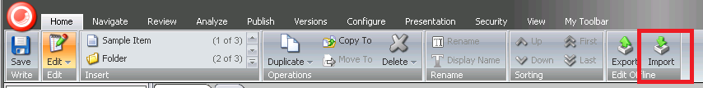

You will be prompted by the Import Wizard. Press the Next button to proceed.

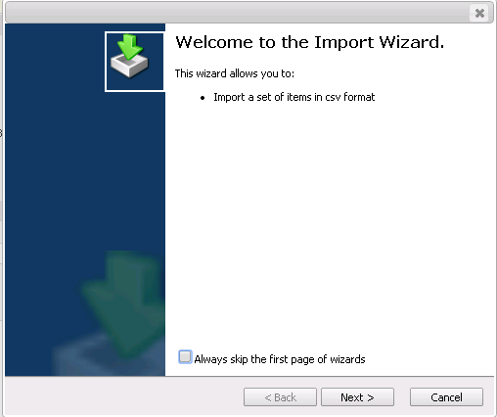

Press the Upload button to select the file you want to upload.

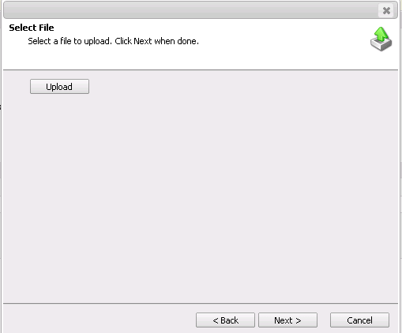

Press the Choose File button to select the file you want to upload.

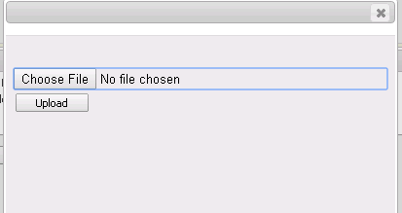

Select the csv file you want to import

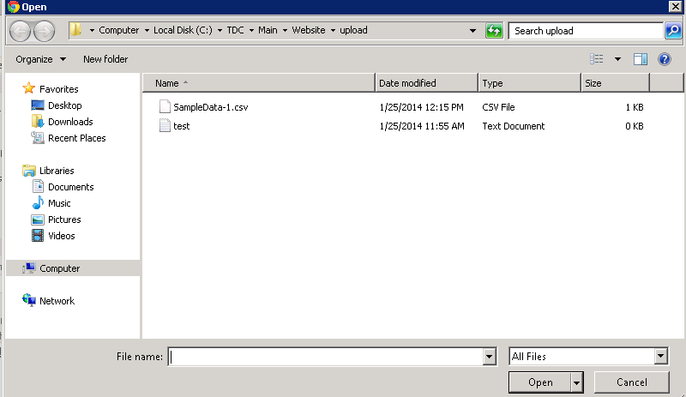

Press the Upload button.

After you press the Upload button, you will be prompted that your file has been successfully uploaded.

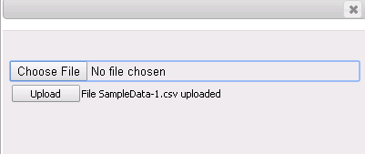

Press Ok and click Next on the wizard.

You will then be prompted with the final step of the workflow. Press the Finish button to complete the wizard.

